# **Syntax 1: Worksheet (Practice Exercises)**

1. Indicate the syntactic category of each word in the following sentences.
   1. The glass suddenly broke.
   2. A jogger ran towards the end of the lane.
   3. These dead trees are blocking the road.
   4. The detective hurriedly looked through the records.
   5. I’ll see you tomorrow because tomorrow is another day.
   6. The peaches never appear quite ripe.
   7. Jeremy will play the trumpet and drums in the orchestra.
   8. He asked why she looked so angry.
2. Vogon Poetry

Here is a piece ofnonsense poetry attributed to a fictional alien race called *the Vogons*. For each of the underlined words, identify its morphosyntactic category (verb, noun, adjective, etc.) and explain what evidence [both inflectional (where possible) and distributional] you used to make your choice.

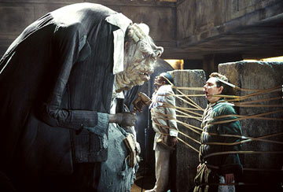

*Oh freddled* ***gruntbuggley****, thy micturations are to me   
     As plurdled gabbleblotchits on a* ***lurgid*** *bee   
Groop I implore thee, my* ***foonting******turlingdromes*** *And* ***hooptiously******drangle*** *me with crinkly* ***bindlewurdles****,*

*Or I will rend thee in the gobberwarts with my* ***blurglecruncheon****, see if I don't!*

From: Adams, Douglas (2003). Geoffrey Perkins (ed.), additional Material by M. J. Simpson (ed.). The *Hitchhiker's Guide to the Galaxy: The Original Radio Scripts (25th Anniversary Edition*). Pan Books. pp. 147. ISBN 0-330-41957-9.

1. Carry out a **grammatical function analysis** of the following sentences:
   1. Mother Hupboard went to the cupboard.
   2. She gave her dog a bone.
   3. Her dog is a boxer.
   4. We are dreading this evening.
   5. They considered him very unreliable.
   6. People call her Susie.
   7. He put the plates down.
2. Using grammatical function analysis, distinguish between the structures of the following pairs:
   1. The porter called me a taxi.

The porter called me a nuisance.

* 1. Merlin was holding a sword with jagged edges.

Merlin was holding a sword with murderous intent.

* 1. Sally seems an interesting student.

Sally knows an interesting student.

* 1. We are dancing this evening.

We are dreading this evening.

1. Identify the types of sentence and clauses in the following examples.
2. She cooked delicious curries.
3. The lecturer asked some challenging questions, but no-one could answer them.
4. I know what you did last summer.
5. Although Angus prefers watching sci-fi films, he rented the latest spy thriller and he enjoyed it very much.
6. You would have passed your exam if you had worked harder.
7. The team captain jumped for joy, and the fans cheered because we won the championship, which the company holds every five years.